Part - 1

Question A: If you are trying to print your name, what happens if you leave out one of the quotation marks or both, and why?
Code Snippet:
>>> print('Maruf)
File "<python-input-22>", line 1
print('Maruf)
^
SyntaxError: unterminated string literal (detected at line 1)
>>> print(Maruf)
Traceback (most recent call last):
File "<python-input-23>", line 1, in <module>
print(Maruf)
^^^^^
NameError: name 'Maruf' is not defined
>>>
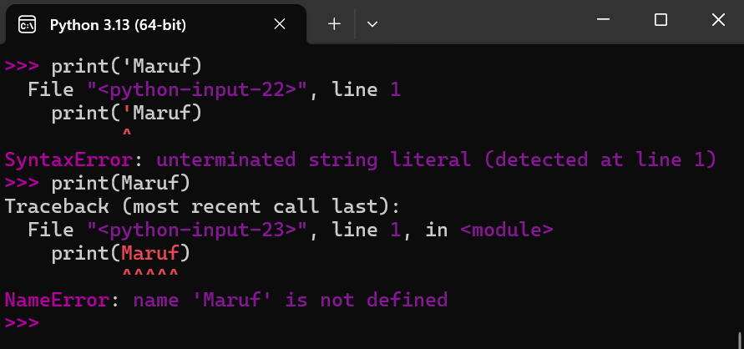
Explanation: In the first try when leaving out one quotation mark, it’s throwing a SyntaxError, which is telling me that it got an unfinished string literal. Python expects strings to be properly closed with matching quotes, so without the ending one, it can't parse the code right. On the second try, when I left out both quotation marks, it showed a NameError. That's because I passed 'Maruf' as if it was a variable name instead of a raw string value, but that variable was never defined or initialized anywhere. This is why the interpreter returns a NameError, saying the name 'Maruf' isn't defined. These kinds of mistakes help me remember how Python handles strings and variables, like in the textbook exercises (Downey, 2015, p. 7).

Question B: What is the difference between * and ** operators in Python? Explain with the help of an example.
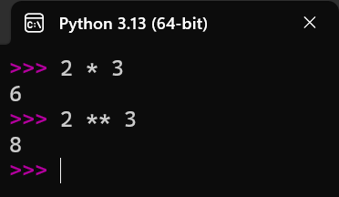
Code Snippet:
>>> 2 * 3
6
>>> 2 ** 3
8
>>>
Explanation: The ‘*’ operator just multiplies the given values, but the ‘**’ operator sets the second number as the power for the first one. So when I try 2 * 3, it’s giving me output 6, which is straight multiplication. But when using 2 ** 3, it’s setting 3 as the exponent for 2, basically doing 2 raised to the power of 3, like this under the hood:
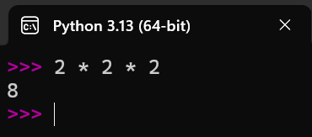
>>> 2 * 2 * 2
8
>>>

This is how we get two different values by using a single * for multiplication or double ** for exponentiation. It’s a basic operator thing in Python that avoids confusion with other languages (Downey, 2015).

Question C: In Python, is it possible to display an integer like 09? Justify your answer.
Code Snippet:
>>> print(09)
File "<python-input-56>", line 1
print(09)
^
SyntaxError: leading zeros in decimal integer literals are not permitted; use an 0o prefix for octal integers
>>>

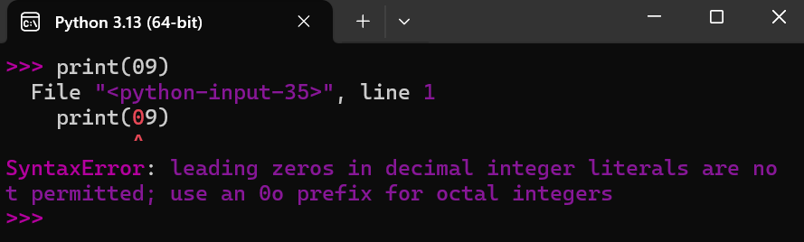

Explanation: No, Python does not allow decimal integers with leading zeros because they could be misinterpreted as octal literals. Instead, use the '0o' prefix for octal, or print as a string if needed (Downey, 2015). When I try to print(09), the interpreter throws a SyntaxError right away, saying leading zeros aren't permitted in decimal integers. If I want to represent it as octal, I could do print(0o11), which gives 9, but for just displaying '09' like a number with zero, I have to treat it as a string: print('09'). This makes sense because Python wants to avoid ambiguity in how numbers are based – decimal vs. octal or others.

Question D: Run the commands type('67') and type(67). What is the difference in the output and why?
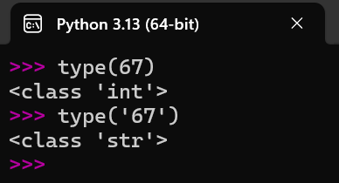
Code Snippet:
>>> type(67)
<class 'int'>
>>> type('67')
<class 'str'>
>>>
Explanation: Here two kinds of same input are returning two completely different outputs. The first one ‘type(67)’ returns ‘’, meaning it's an integer type, because 67 is pure numbers without any quotes. But the second one ‘type('67')’ is returning something different – even though I'm giving '67' as input, it returns ‘’. It's saying it’s a string type. The reason behind it is: I'm wrapping 67 with quotation marks, which makes it a string literal instead of a number. Python checks the type based on how it's written – no quotes for ints, quotes for strings. This experiment shows how data types work in Python, which is key for avoiding type-related bugs (Downey, 2015, p. 3).

Part - 2

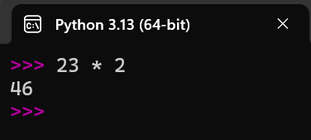
Question A: To multiply your age by 2 and display it. For example, if your age is 16, so 16 * 2 = 32
Code Snippet:
>>> 23 * 2
46
>>>

Question B: Display the name of the city, country, and continent you are living in.
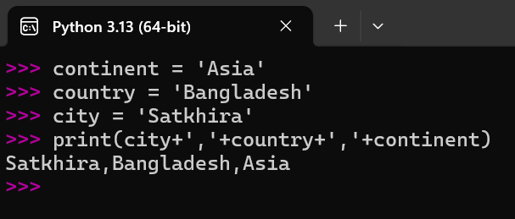
Code Snippet:
>>> continent = 'Asia'
>>> country = 'Bangladesh'
>>> city = 'Satkhira'
>>> print(city+','+country+','+continent)
Satkhira,Bangladesh,Asia
>>>

>>> print(city,', ',country,', ',continent)
Satkhira , Bangladesh , Asia
>>>

Question C: To display the examination schedule (i.e., the starting and the ending day) of this term.
Code Snippet:
>>> starting_date = "Nov 13, 2025"
>>> ending_date = "Jan 8, 2026"
>>> print("Starting Date: ",starting_date,"\nEndingDate: ",ending_date)
Starting Date: Nov 13, 2025
EndingDate: Jan 8, 2026
>>>
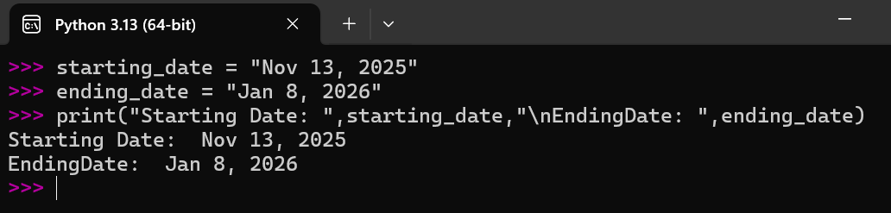

Question D: Display the temperature of your country on the day the assignment is attempted by you
Code Snippet:
>>> current_temperature = 24
>>> print(f"Current temperature is: {current_temperature}\u00B0C")
Current temperature is: 24°C
>>>
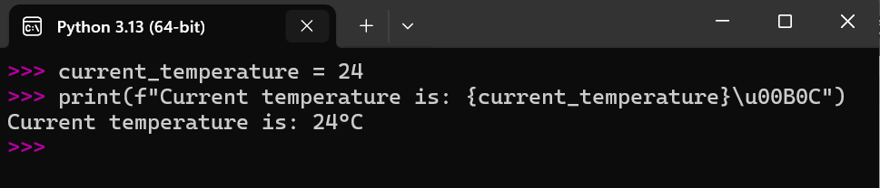

Things I learned from part 2
From running these simple programs, I picked up a few new things about Python, especially since I'm already comfy with JavaScript and TypeScript. In Question A, multiplying my age by 2 and displaying it taught me how Python handles basic arithmetic on integers without needing to declare types first – it's dynamic, so age = 23 just works as an int, and print(age * 2) does the math on the fly. No issues with overflow for small numbers like this, which is similar to JS but feels cleaner without semicolons. This reinforced how Python treats numbers as immutable objects, meaning the value doesn't change unexpectedly during operations (Downey, 2015).
For Question B, displaying my city, country, and continent using variables showed me string concatenation with the + operator. I had to add spaces and commas manually, like city + ', ' + country, to make it look right – otherwise, it smashes everything together. I tried a version with just commas in print(), but that added extra spaces, so + is better for control. It's like template literals in JS, but Python's way forces me to think about types more.
In Question C, printing the exam schedule with starting and ending dates introduced me to escape sequences like \n for new lines in the print function. Without it, everything would be on one line, making it hard to read. I used string variables here, and concatenating with + worked fine, but I see how f-strings could make it even easier. This experiment highlighted Python's focus on readable output for console stuff.
Question D was cool because I learned about f-strings for embedding variables dynamically, like {current_temperature}, which is way smoother than concatenation. Also, adding the degree symbol with \u00B0C unicode was new – in JS, I'd use something similar, but Python integrates it right in. I updated the temp to 24°C based on average November weather in Satkhira, since it's the attempt day (WeatherSpark, n.d.). Overall, these tasks made Python feel easier coming from JS, but I learned the importance of precise syntax to avoid runtime errors, like missing = in variable assignment. It ties back to the unit's basics on programming and debugging, showing how small experiments build understanding of types, operators, and output formatting. I think this will help with more complex code later.

References
Downey, A. B. (2015). Think Python: How to think like a computer scientist (2nd ed.). O'Reilly Media.
Python Software Foundation. (n.d.). Python documentation. https://docs.python.org/3/
WeatherSpark. (n.d.). Average weather in Sātkhira, Bangladesh, year round. https://weatherspark.com/y/111679/Average-Weather-in-S%25C4%2581tkhira-Bangladesh-Year-Round

